Analysis of Urine Samples to predict Dehydration using Image Processing and XGboost

Mohammed Azam Sayeed¹, Noor Ayesha², Sakeena Fiza³
& Mohammed Akram Sayeed⁴
¹ CSE Graduate of SET Jain University Bangalore -562112
³Undergrate Student at UC berkeley.

Abstract:This paper presents a Methodology which classifies urine samples into normal hydration or dehydration level using image processing techniques and XGboost ensemble boosting model. Images of urine samples were captured by digital camera and processed through image acquisition, color transform, image segmentation and feature extraction procedures. Suitable Features are extracted which serves as train set and test set for XGboost model which can be improvised using feature importance. Methodology is a valuable alternative to Standard Laboratory test for dehydration being Econimical, faster, efficient and reliable.

Introduction
Water is a critical ingredient for our survival and its absence or even its presence in excess will very quickly prove to be lethal to our mortality. Heat Waves and Dehydration in the Elderly from the BMJ: British Medical Journal states “Dehydration with or without concurrent electrolyte disturbances in itself is an important cause of death, but it is also an important factor in most other causes of death,” (Rikkert 119). The hydration status serves as an indicator of the diseases an individual has. Dehydration has been linked to several ominous disorders such as but not limited to; gastrointestinal, circulatory, urological and neurological disorders. Whereas, fluid overload poses a prominent threat in terms of hyponatremia, edema, cardiopulmonary disorders, and postoperative complications.

The Present Systems to estimation dehydration levels of patients such as Blood test and Urinalysis have major drawback of not being economical, time consuming and not flexible approach. This paper will propose an alternative Methodology to classify urine sample to normal hydration or dehydration level in a economical, faster, efficient and reliable way for both patients and health workers.
The Paper evidences the employment of an innovative system to identify if an individual is dehydrated and normal levels of hydration. The technology is advanced and more efficient than traditional lab methodology and more reliable than conventional eye observation. It involves the acquisition of digital images of urine samples, followed by image processing for featuring extraction and implementation of the XGboost model. The automation of the identification of the hydration status of a patient will prove to be extremely helpful as health-care outcomes will exponentially improve and will be complemented with cost reduction. This automated technology can be utilized by doctors and even the general population as a convenient and economical method to keep track of electrolyte and hydration levels. This will allow patients to take pre-emptive measure to quickly replace lost body fluids. The implementation of this novel and advanced algorithm would radically change the state ambiguity surrounding the relationship between hydration status and diseases and serve as a catalyst to further study and understand dehydration and normal hydration.
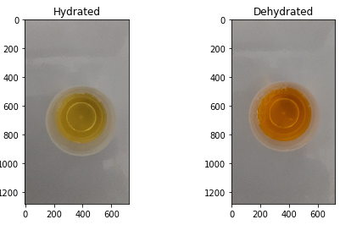
Figure 1. Targets for classification

Implementation of XGboost Model for Supervised Learning

Introduction to Ensemble Approach
The Ensemble approach combines several base models in order to produce one optimal predictive model rather than depending on singular model built for prediction. Instead of building one model for the entire dataset, Ensemble approach is dividing the dataset into an n Training set and build a model on each Training set, then we take an aggregate of output of the individual models for decision.
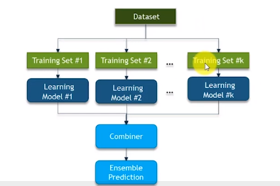
Figure 2. Ensemble Prediction.
There are two techniques in Ensemble –

Bagging
Technique which works on Sampling with Replacement of dataset. Mutiple Models such as decision trees are modeled based on multiple dataset generation via sampling with replacement. The concept can be understood from below example
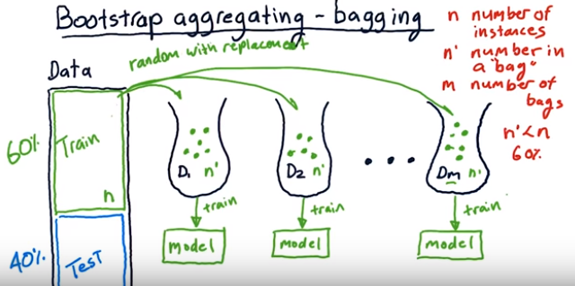
Figure 3. Process of Bagging
From n records in Data like [x,y,z,a,b,c], we pick n’ several samples to fill D1 such that n’<n also n’ is randomly selected set with repetition , ex: D1 could contain [a,a,x,y], D2 : [b,a,x,x] etc.
Create m set of dataset with same number of n’ samples. For each of dataset x model a decision tree. Suppose we need to predict for new set R then we will get r number of prediction from each tree created from bags. Then classify based on highest votes/aggregated result from each model.

Random Forest is an ensemble technique that works on Bagging

    - Boosting
Boosting is the process that uses a set of machine learning algorithms to combine weak learners to form strong learner to improve accuracy of Model. Unlike Bagging where the weak learners are trainied sequentially, in boosting weak learners are trained in parallel and has weighted Samples.
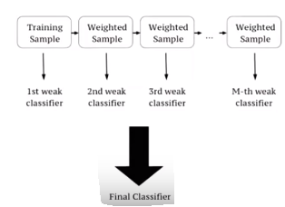
Figure 4. Weak Learners in Ensemble

The Concept of boosting can be understood in below example of Ada Boost
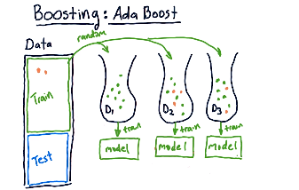
Figure 5. Boosting
Create First Bag of Data D1 randomly from Train Data. Model m1 is trained using D1. The variation from boosting is that then model is tested using all the data points from train set , using this we discover points which didn’t classify well using M1( highlighted in pink). These error points for the weighted dataset for next sequential model M2 which will be modeled on bag D2 having more likely variations of error data points. Then Entire Train Data is tested on both sequential models M1 and M2 ,in turn find the next set of Incremented weights/Error points which will be used for next Bag and subsequent model. Process is repeated for desired m sequential weak learners.

Summarizing Ada Boost
Step1: Each data point is weighted equally for the first Bag
Step 2: Train Model , test entire Train dataset against the model and Mis classified data labelled with higher weights
Step 3: New Bag is drawn by considering higher weight data points. Repeat step 2
Step 4: The process of sequential model generation continues till all data points are classified correctly

Gradient and XGBoost intuition
Gradient Boost is a Sequential ensemble model in which the base learner generated sequentially is always better than previous one. Difference between Gradient boost and Ada Boost is the Weights of Misclassified outcomes are not Incremented Instead it optimizes loss function of previous learner by adding new Adaptive Model (Additive Model) that reduces the loss function. Aim is to Reduce Error/log function of previous weak learner in improve performance

XGBoost was introduced as a variation of Gradient boosting as it is bit slow due to many sequential operations. XGBoost is an advanced version of gradient boosting focused on Computational speed and efficiency. It uses Parallelization,Distributed computing and optimized cache utilization for better performance

For our application of urine analysis , we will use xgboost for implementation. Xgboost as an Ensemble boosting algorithm works well for image processing problems because of the concept of multiple weak learners, each weak learner modelled for combinations of feature datapoints will result in better throughput and also having better performance advantage over gradient boosting.

Proposed Methodology
The Methodology can be broadly explained in two steps- Image processing techniques for feature extraction and Implementing Xgboost model. Python jupyter notebook is used as Prototype software. Skimage and Scipy packages is used for image processing because it represents images as Numpy arrays which makes image processing much more understandable and gives us the ability to do various powerful image processing operation on images as pixel data represented as nxm array.Then the data collected from image processing will be used build Xgboost Ensemble boosting algorithm for prediction of urine samples into distinct target classes of Hydrated or Dehydrated.
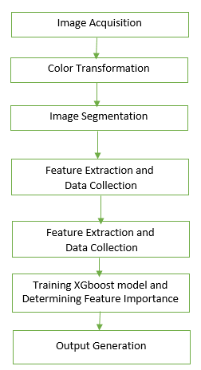
Figure 6. Proposed Methodology Flow Diagram

Image Acquisition
Images were acquired using a digital camera with at least five megapixels of resolution. Urine Sample of patient is to be taken in standard Urine test container used in diagnostic lab. Although the
Algorithm is robust of any background texture, reflections and shadows of Images of the Container but preferably to take sample images with background of consistent tone like shades of white or gray.
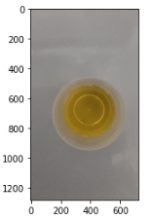
Figure 7. Input Image – Urine Sample

Color Transformation
After the acquisition of image, RGB image is converted various color space which will be the basis for further processing on image. Few of the experimented transformation to various color spaces are depicted in figure. As we can notice in grayscale color, There is distinction between object and background but still has effects of shadow and background reflections. Enhanced color space is HSV but is not robust against background noise and sharp intensity changes. After Observing multiple color spaces , results conclude Individual extracted Saturation component from HSV is the best choice for the methodology.
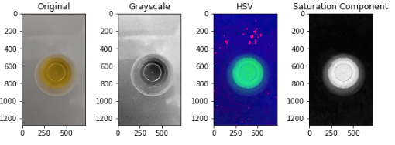
Figure 8. Various Color Transformation
Saturation is similar to the concept of tint, except that full saturation produces no tint, while zero saturation produces white, a shade of gray, or black.

Image Segmentation
Objective of Segmentation step is to extract Region of Interest (object) from the background such that there is Minimistic loss of data and erroneous data points in analysis making image data is more meaningful and easier to Extract features from. Methodology suggest to use Ostu Thresholding for segmentation on the Saturation Component Image, Our observation is algorithm will generate better segmentation result when threshold used for segmentation is slightly higher than calculated (thresh+15) as it effectively excludes the Container boundary and froth (if any) for Image Segmentation.
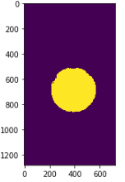
Figure 9. Segmentation using Ostu’s Algorithm
Alternative Morphological snakes techniques can be used for segmentation such as chan_vese where Active contours without edges implemented with morphological operators. It can be used to segment objects in images and volumes without well defined borders. It is required that the inside of the object looks different on average than the outside (i.e., the inner area of the object should be darker or lighter than the outer area on average).
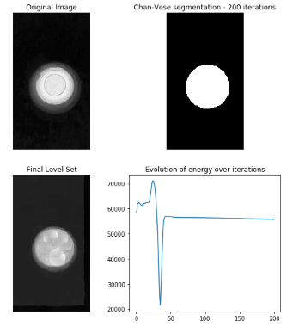
Figure 10. Morphological snakes –Chan Vese

On the contrary, MorphACWE works well when the pixel values of the inside and the outside regions of the object to segment have different averages. Unlike Chan vese, MorphACWE does not require that the contours of the object are well defined, and it works over the original image without any preceding processing.
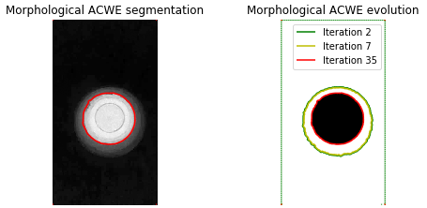
Figure 11. Morphological snakes –ACWE

Since the Methodology primary focus is on performance and accuracy we chose Ostu’s algorithm for preferred segmentation algorithm as it is way more faster in performance as no Iterations required unlike Morphological Snake.
The segmented image will be used to extract ROI from RGB image, such that only the segmented reqion will retain original values and the background values will be zero, which make the process of Feature Extraction quite efficient, robust and accurate
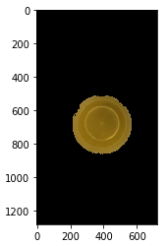
Figure 12. Final Segmented Image using Ostu’s Algorithm

Feature Extraction and Data Collection
From the Segmented Image we take the mean values of non zero pixel values for various components of multiple colorspaces. 11 Colorspaces were considered in Feature Extraction taken as Mean non zero array values rounded to 4 decimal places are RGB, HSV, XYZ, RGB cie, Gray, LAB, YUV, ycbcr, yib, ybpr and ydbdr scale (y can be excluded from yib, ybpr, ybpr and ydbdr as it has same value as Y in YUV) . Since we have Image Features extracted for various colorspaces the model is far more accurate and reliable than eye observation and far more convient and faster than traditional laboratory methods for electrolyte and dehydration on urine samples. Saves effort ,time and money for patient to keep accurate accessments on body hydration levels so that preemptive measures can be taken to quickly replace body fluids.

Each Component of above mentioned 11 colorspaces gives us 28 features and one target variable 0- Hydrated levels and 1- Dehydrated levels. The same process is used for Data Generation and Collection. Urine Sample Images were collected from a diagnostic laboratory such that 15 images had various level of normal hydration level and 15 images of dehydration level of affected patients. Methodology steps of 4.1,4.2,4.3 and 4.4 were repeated iteratively for all 30 images and generated features data values were stored in csv format using the Pandas package in python.

Feature Scaling
This is an additional step in Methodology which is optional, we chose to include in the algorithm because few features such as R,G,B and cb,cr components have higher scale then other component values. Feature scaling will avoid bias of model to higher measure features for target prediction. MinMax scaler was used in algorithm. Note if this step is included for implementation we need to perform scaling to test and validation dataset as well before prediction as the trained model will be based on scaled trainset.

Training XGboost model and Determining Feature Importance
from sklearn.preprocessing import MinMaxScaler
scaler = MinMaxScaler()
scaled_data = scaler.fit_transform(X)
Figure 13. MinMax scaler
Prototype uses the Pandas package from python to create dataframe. Data frame is convenient way to handle dataset. Sklearn package is used for train_test_split for splitting data into train and test to 70% as train data and 30% as test data.
from sklearn.model_selection
import train_test_split
x_train,x_test,y_train,y_test=train_test_split(X,Y,test_size=0.3)
Figure 24. train_test_split.
where X is the Features and Y are the corresponding targets having 0,1 representing hydrated and dehydrated correspondingly.
We then use the train set to build the Xgboost model using the Sklearn package. Variables in xgboost can be altered and changes can be observed for tuning model.
#pip install xgboost
import xgboost as xgb
xgbc=xgb.XGBClassifier(n_estimator=10,max_dept=5)
xgbc.fit(x_train,y_train)
y_pred=xgbc.predict(x_test)
Figure 15. Xgsboost model.
Y_pred/Prediction on x_test can be compared with actual values y_test to evaluate the metrics for the trained model
Confusion matrics and accuracy can be to determine the model efficiency in prediction.

Improvising XGboost model

XGboost has an fascinating feature of finding the feature importance which conveys which features contributed the most for predicting the Targets.

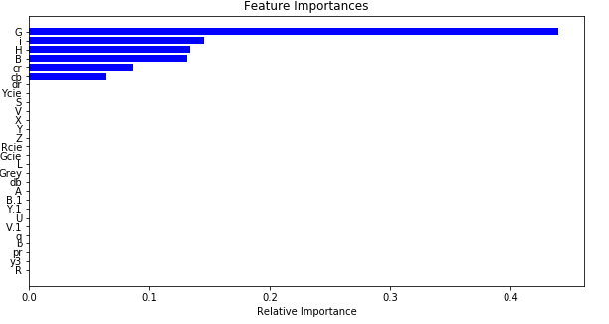
Figure 16. Feature Importance on scaled data
On the scaled Dataset, Xgsboost says that the best contributing features for prediction are G,i,H,B,cr and cb

4.6.3. Results of Feature Importance
After Feature importance insights Xgboost was trained with only G,i,H,B,cr and cb features. There was a very slight improvement in accuracy as Xgboost ensemble boosting method is already a efficient, optimized algorithm based on several weak learner to make stronger prediction. So Feature importance is an optional step in the methodology.

Results and Discussion
The proposed system was validated using 4 sample as validation set for unbiased validation. The Prototype correctly classified the images to correct targets as hydrated or dehydrated with very high accuracy level as +97.5%.

Table 2. Table example.
Sample | Expected | Target Prediction
1. | hydrated | 0
2. | dehydrated | 1
3. | dehydrated | 1
4. | dehydrated | 1
 |  | Average =4/4

Future Scope
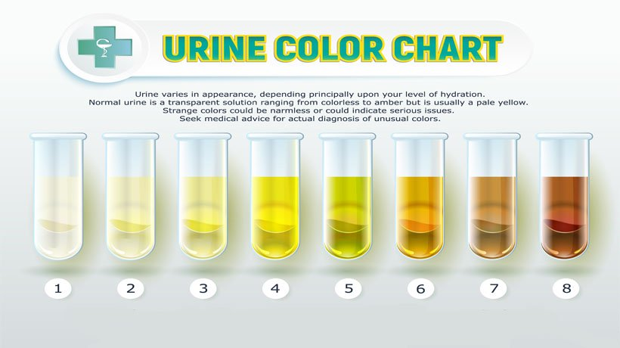
Figure 17. Future scope of Methodology

This Algorithm can be extended to in dept analysis of urine samples after researching futher in Image processing and Feature Extraction . Instead of
For Classification of Urine to many distinct classes signaling its corresponding medical interpretation and corresponding diagnosis.

References
[1] Rikkert, Marcel G M Olde, et al. “Heat Waves and Dehydration in the Elderly.” BMJ: British Medical Journal, vol. 339, no. 7713, 2009, pp. 119–120. JSTOR, www.jstor.org/stable/25672092.https://academic.oup.com/nutritionreviews/article/73/suppl_2/97/1930742
[2] Mohammed Azam Sayeed & Shashikala G2, Sakshi Pandey,Ruhi Jain & Satish Kumar N," Estimation of Nitrogen in Rice Plant Using Image Processing and Artificial Neural Networks", Vol-2, Issue-8, 2016 ISSN: 2454-1362, http://www.onlinejournal.in,IJIR
[3] A Satish Kumar N, Sakshi Pandey, Ruhi Jain, Mohammed Azam Sayeed & Shashikala, “Detection of Weeds in a Crop Row Using Image Processing ”, Vol-2, Issue-8, 2016 ISSN: 2454-1362, http://www.onlinejournal.in, IJIR

